A Summary of Rotary Friction Welding

[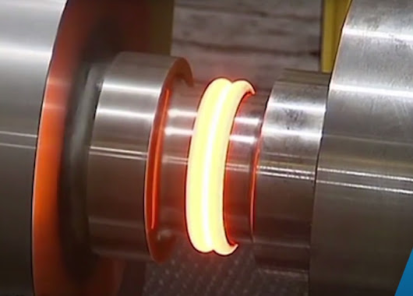](https://www.google.com/url?sa=i&rct=j&q=&esrc=s&source=images&cd=&cad=rja&uact=8&ved=&url=https://declara.com/collection/53b29dc3-d58a-4f04-91e4-2dd21c63f037/post/e3c5107c-0c4b-46e1-a3fa-b8e03863525f&psig=AOvVaw2Z70g_QzEwReFcL4TzwQJF&ust=1542085977646517)

Matthew Fattibene

15 November 2018

MEEG453

Summary: Friction welding is a solid state welding process which requires an automated machine to drive a tool or part, generate high heat, and join two solid bodies to one another. There are three primary types of friction welding: rotary, linear, and stir. For this report, I will choose to only discuss rotary friction welding. Rotary friction welding is relevant in my life because my former employer has purchase a rotary friction welding machine, and I would like to take the opportunity to educate myself on the manufacturing technique. In this report, I will discuss how friction welding got its roots in the U.S.S.R, how machines are capable of bonding two metals together, and the limitations and advantages of the growing technology.

**Brief History:**

The history of friction welding begins in the U.S.S.R during the 1950s. Unlike conventional welding techniques such as MIG and TIG welding, friction welding is a purely mechanical process that does not require an electric arc to create molten material. As a result, in 1954 the first successful test of friction welding took place using a modified lathe and round metal bars. The lathe needed to be modified in order to create adequate pressure between the contact surfaces. Once the technology was further developed it moved across seas and the first North American company to publicize the construction of a friction welding prototype was American Machine and Foundry (AMF). Today, AMF is most recognizable because their logo is on bowling lanes across the United States. In 1964, the Friction Joining Research Conference was founded (still active today) and shortly after in 1967 Milton Hollander of AMF received a patent for his Friction Welding Machine (Figure 1). Other notable leaders in the friction welding industry throughout the 1970s-1980s include Caterpillar and Manufacturing Technology Inc. (Figure 2). Today, friction welding has continued to grow as a prominent alternative to traditional welding techniques.

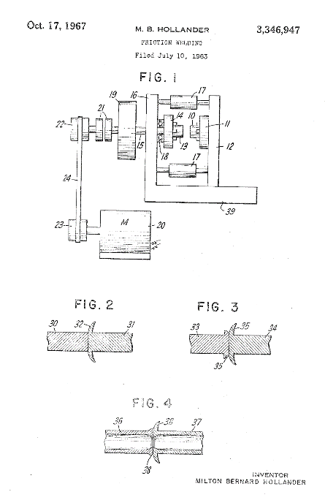

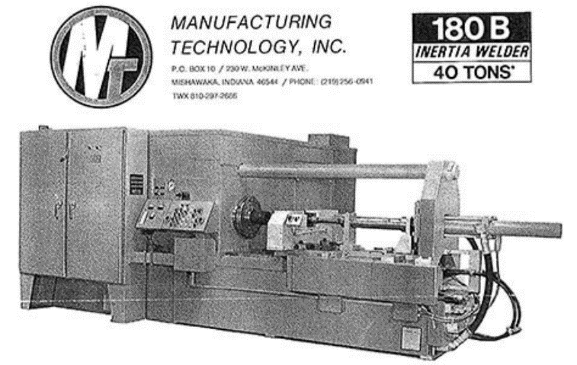

**Figure 1:** Hollander’s Patent **Figure 2:** MTI friction welding machine

**The Machine:**

There are two main types of rotary friction welding machines – direct drive and inertia. Both machines are most closely related to a lathe because a part is held in a jaw or collet chuck and rotated to perform the operation. However, unlike a lathe there are no cutting tools which come into contact with the rotating part. Instead, the other piece of material to be welded is held stationary and is pressed into the rotating piece via a hydraulic cylinder. This cylinder will operate at a specified pressure and exact duration to achieve the desired weld formation. Most often, a friction weld machine is rated depending upon the maximum force the hydraulic cylinder can provide. This force can range anywhere from 6-450 tons. The machines are also classified by the size of their chuck. A solid diameter cross section (seen most often with rotary friction welding) can range anywhere from 0.250” – 6”. These larger friction welding machines can exceed a total weight of 450 tons (Figure 3).

With a direct drive machine, the rotating material is under the power of the motor throughout the entire welding process. Once the desired weld is formed, breaks are applied to the motor and rotation stops to prevent the welded material from experiencing any torsional forces. With an inertia machine, the rotating material is connected to a large, heavy flywheel. Prior to contact between the materials, a motor brings the flywheel up to the proper rotational speed and will then disengage. When the materials being to bond with one another, the flywheel will begin to slow and eventually stop once the bond has been formed.

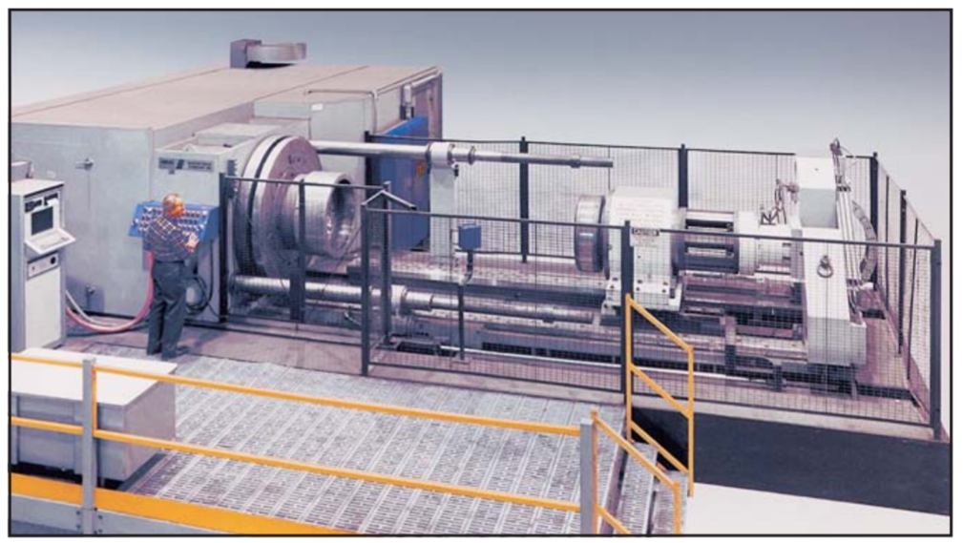

**Figure 3:** Model 400s Inertia Friction Welder from MTI

**The Process:**

The friction welding process is divided into two stages know as Friction Heating and Welding (Figure 4). The primary variables which are controlled during these stages include angular velocity and axial force. These variables are dependent on part geometry and material type and are controlled by preprogramed instructions given to the machine.

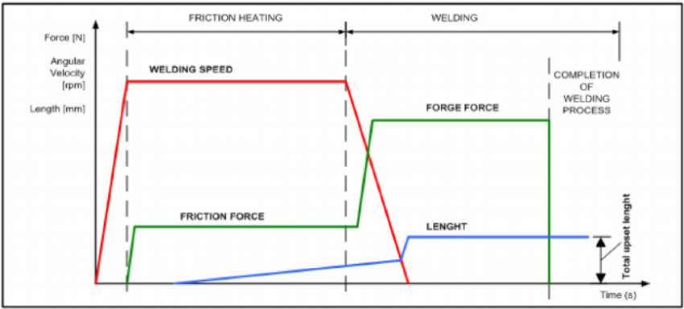

**Figure 4:** schematic showing the relationship between angular velocity, axial force, and upset length during the friction welding process

After the material is loaded into the machine, the rotating part is accelerated to the proper angular velocity. Once this speed is reached, it is held constant while the two materials come into contact. This contact marks the beginning of the Friction Heating stage. The stationary part will apply a constant axial force to the rotating part. This force is not incredibly strong, but is necessary in order to generate heat between the two surfaces via friction. As the temperature of the interface rises, the atoms in the materials begin to change positions and the material properties of the metals change.

Once the proper temperature is achieved, the Welding stage begins. The stage is best define as a rapid deceleration of angular velocity and a simultaneous increase in axial force. The force is known as the forging force and is substantially greater than the forces experienced during the Friction Heating stage. Another consideration is a factor called upset length. Upset length is define as, “the distance the two pieces move inward during welding after their initial contact” (Schmid). When the angular velocity is zero, and the forge force is applied, the material experiences the greatest change in upset length. As a result, the materials bond to one another and are now one continuous piece.

Once complete, the finished product is shorter than the sum of the original lengths of the material. Due to conservation of mass, this material expanded out of the interface between the two materials when the forging force was applied. As a result, a band of material known as a flash forms on the exterior of the rod. The flash does not have any mechanical attributes and is removed using conventional machining practices.

**Economic Impact:**

Friction welding requires high up front capital expenses for companies integrating the technology into their production line. The cost of the machine is significantly greater than traditional welding equipment. However, it is important to consider the labor costs associated with a friction welding machine. Friction welding machines are generally operator friendly and an individual can be trained on the machine relatively quickly and inexpensively. With traditional techniques such as Oxy-Acetylene or GTAW, the operator is required to have precise control of the weld puddle to produce a quality weld. The expense to train and certify the operator can be multiple times more expensive than friction welding training.

Furthermore, friction welding can be considered a repetitive process with a high level of flexibility since different material types can be combined with minimal changeover time. This combination is ideal in order to reduce cost and improve productivity. Productivity is also promoted since the cycle time of friction welding is generally a few seconds. Traditional welding procedures may take several hours to complete depending on the geometry and the material of the base metals. Since the process is solid state, all recurring costs of traditional welding practices are avoided by excluding the consumption of shielding gas or filler material. Lastly, friction welding reduces cost of poor quality because no melting takes place. Melting is often associated with defects such as porosity, lack of fusion, and weld splatter.

**Relevance:**

The significance of this topic for a beginner engineer is to explore the effects of friction as a joining force for solid bodies and observe conservation of mass with the creation of a flash as a byproduct from the process. Furthermore, friction welding is a good example of a CNC manufacturing process.

The significance of this topic for an advanced engineer would be to explore the physical, visual, and metallurgical properties of the weld’s Heat Affected Zone (HAZ). Another interesting observation would be the comparison between a friction welding and conventional welding HAZ. Some of the primary differences is that a friction weld HAZ is less extensive and is narrower (Figure 5). In addition, the HAZ is free of gas porosity and avoids grain growth. These two properties demonstrate how a friction welding operation provides greater material strength than conventional welding techniques.

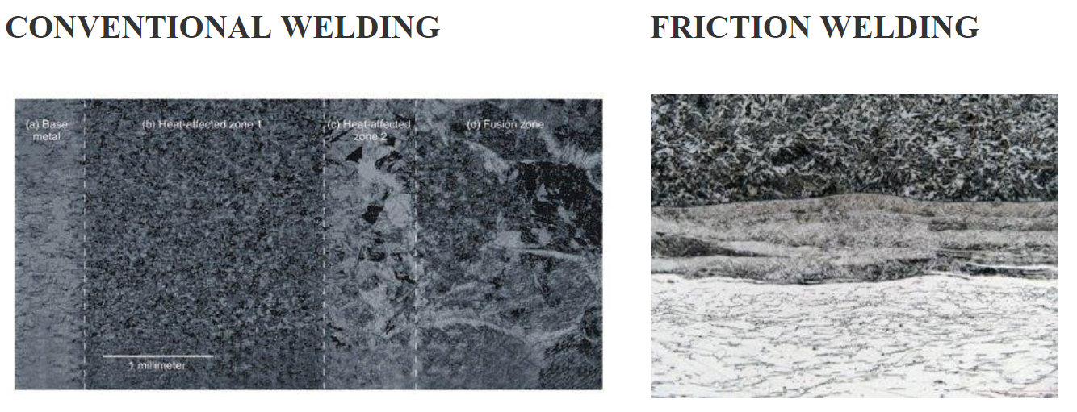

**Figure 5:** shows the narrow HAZ and the reduced number of layers present in weld formation

**Learning:**

I learned friction welding devices can weigh up to 450 tons by investigating the companies I discovered while researching friction welding history. In particular, I noticed MTI is regarded as the leader in heavy duty, large application machines capable of welding jet engine components. I then read through MTI’s parts catalogue to find the specifications of their machines. MTI’s top tier machinery is the largest contract service welder used in the U.S. and tips the scales at approximately 450 tons.

**Works Cited**

Afw. “The Friction Welding Process | Team AFW.” *American Friction Welding*, American Friction Welding, 2 May 2018, teamafw.com/friction-welding-process/.

“Friction Weld Process: Welding Videos and Free Guide.” *Weldguru.com*, weldguru.com/friction-weld/.

“Grain Size and Material Strength.” *Technical Tidbits*, Brush Wellman Alloy Products, Mar. 2010, materion.com/-/media/files/alloy/newsletters/technical-tidbits/issue-no-15---grain-size-and-material-strength.pdf.

Izumi Machine Mfg. JAPAN. “Innovators in Friction Welding Solutions Toyota Industries Corporation Group.” *History of Friction Welding｜Izumi Machine Mfg. JAPAN*, [www.en.izumi-mfg.co.jp/fw/about/history.html](http://www.en.izumi-mfg.co.jp/fw/about/history.html).

M, Bob. “Effects or Differences of HAZ (Heat Affected Zone) between Conventional Welding and Friction Welding.” *Spinweld, Inc*, 30 June 2014, [www.spinweld.com/effects-differences-haz-heat-affected-zone-conventional-welding-friction-welding/](http://www.spinweld.com/effects-differences-haz-heat-affected-zone-conventional-welding-friction-welding/).

Manufacturing Technology Inc. *Friction Welding*. *Friction Welding*, Manufacturing Technology Inc.

“Rotary Friction Welding.” *MTI Welding*, www.mtiwelding.com/technologies/rotary-friction-welding/.